1.
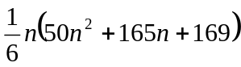

2.
Prove using mathematical induction.

3.
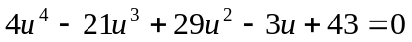

4.
Asymptotes : 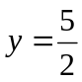 , 
Axial intercepts : 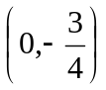 , 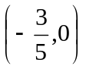
The function is decreasing.

